Williamsburg, VA
September 4, 2006

Dear Director:
Much of this letter was originally written in October of 1999 to the FDA Director and some members of Congress and public servants, to tell you of my experience of being poisoned with the mercury dental amalgam placed in my teeth. I also wrote to urge you to become active about this issue to protect all citizens against this serious public health threat.

As yet nothing has been done officially about the issue. More dentists are not using mercury to fill cavities, but it remains to be a choice for the practitioner, with many unknowing patients maybe getting to make a choice, with many insurances, like my own, paying only for the full cost of the cheaper mercury.

Dentists where I live are still splattering mercury as mercury fillings need to be restored; they’re still adding various metals to mouths with mercury fillings and setting up electrical circuits with mercury fillings.

Thousands of scientific research papers have been published in various parts of the world verifying mercury’s toxic effects as released from these dental fillings. For years the World Health Organization has been recommending that mercury be banned from dental use.

Although the American Dental Association claims studies have been done to prove its safety, it has no list. It is now possible to measure mercury vapor in the mouth with the mercury vapor analyzer showing how significant the release it.

Meanwhile I, myself, along with many other have experienced symptoms with mercury placement and felt improved functioning immediately upon getting up out of the dental chair after mercury removal. Below is my personal story.

In the winter of 1993 I began having bilateral arthritis symptoms during the time period I began being treated by Dr. L of Newport News, VA. As time went on more of my joints became painful and began taking 2 medications through a local rheumatologist. Nothing was seen on any x-ray to show a cause for all this pain. None of the pain was around my face or head so I didn’t connect it all with dentistry.

In 1997 after extracting a tooth, breaking it in the process exposing me to a huge glob of mercury, the same Newport News dentist placed a palate of metal in my mouth. I did not feel anything bad when I initially began to wear the device. I still have the device.

In 1998 after having evidence of mercury poisoning, I told my dentist that I had discovered a high level of mercury, suspected my teeth to be a major source of the mercury, and wanted to know which metals were in the palate. She explained dentists have been putting mercury in teeth for over 150 years without proof of any problem, and that she could lose her license by taking it out of my mouth.

White gold, titanium, and palladium are in the palate which I still have, but do not wear. I did not feel anything bad when I initially began to wear the device.

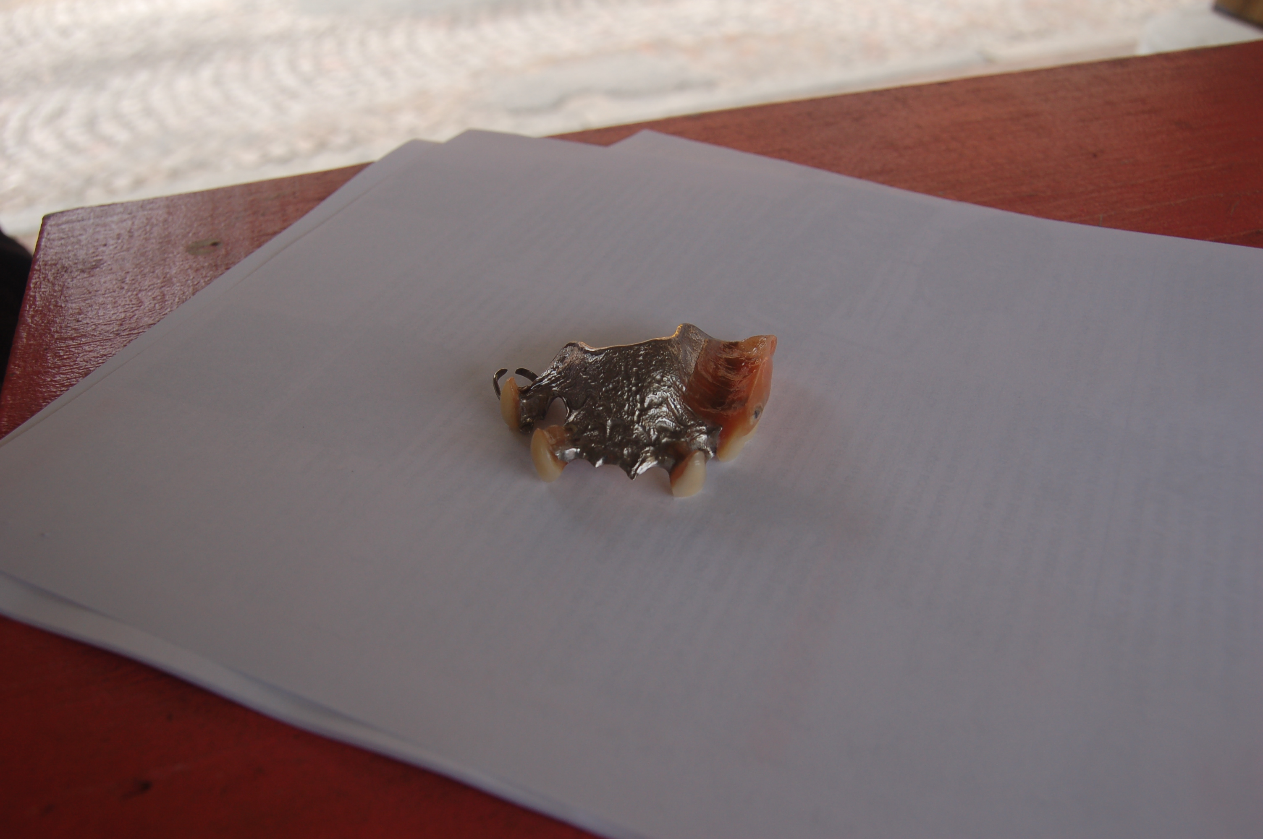
A partial plate made with palladium, a very toxic metal. This one was similar to the one that helped to poison Linda.

A man at the Farmer’s Market in Richmond took out his partial plate to show us when we told him dissimilar metals was the reason for the metallic taste in his mouth. We told him this partial plate would poison him and referred him to a biological dentist in Richmond.

When dentists mix metals in the mouth, oral galvanism occurs, causing an electrical battery like effect in the mouth, releasing more mercury.

I began doing my own independent research as the number of unexplained symptoms increased. Because there was no medical reason, I requested a hair analysis from an out-of-state health care practitioner. When I stopped wearing the palate there was some improvement, which led me to continue with the dental investigation.

The results showed a very high level of mercury. I also had a test done showing the negative electrical charges “oral galvanism” coming from my teeth. (I still have the test results, but I do not have the technology to transmit it to you here.).

I first questioned my dentist of 5 years practicing in Newport News, VA. It was she who had advised me to have some old corroded fillings replaced, and drilled out the “old” mercury to expose me to more mercury and then put in “new” mercury which leaches more mercury than “old” mercury.

I did not question this practice because when I had been a patient at the Medical College of Virginia School of Dentistry from 1979-1984, they had recommended and done some of the same things. And I didn’t know about mercury in dental materials.


Now Linda shares with people at the historic Farmer’s Market in Richmond, VA about the harmful effects of mercury mixed with toxic metal likes palladium.

The dental school in Richmond is still teaching dentists to poison patients because dentists are still using mercury and mixing toxic metals together in one mouth.

I next approached the clinic at the MCV School of Dentistry in Richmond for care in January of 1999. Three gray-haired faculty members who looked briefly into my mouth told me the results of my hair analysis were “worthless, and part of a scam.” No one would remove mercury.

And as for the mercury-filled tooth sometimes feeling achy, they said they would probably cover that with a gold crown. More metal! Fortunately I did eventually find some real health care – compassion and knowledge of mercury within this state. On four successive occasions of mercury removal I immediately felt relieved of some symptom upon standing up out of the chair:

chronic fatigue
difficulty walking and maintaining erect posture
limping
feeling as though my head was transmitting electricity
feeling as though my brain was being ripped in half
feeling as though my brain was being fried
earaches or burning ears
aching in most of my teeth – with 16 mercury fillings in my mouth
feeling as if my head was as big as a large balloon
swollen, painful-to-the-touch lymph nodes in the neck and back of head
allergies to most foods
burning sensations in various parts of my body.
I continued to improve my functioning using non-traditional therapies.

Your agency is wrong for failing to do an environmental impact statement, as the law requires about the #1 source of mercury in wastewater and failing to classify mercury fillings as hazardous, violating a legal duty.

I am sincerely glad I no longer need to support the prescription drug companies with all their side effects for the arthritis which was actually mercury poisoning.

Sincerely,
Linda Cifelli

Do not go to a regular dentist to remove mercury fillings. Contact DAMS for a safe biological dentist who will protect you from mercury vapor. 651-644-4572

